RC tutorial 007 - Flexible tubes

=========================

Revised 2022-10-20

* This tutorial's goal is to teach you how to create flexible tubes.
* Assumed RailCOMPLETE skills: Draw alignment, offset alignment.
* Assumed railway skills: You are familiar with cabling, cable ducts and flexible tubes. You know the concept of an alignment, involving horizontal geometry and vertical profile.
* Time to spend here: Newbie: 1 h / Intermediate: 30 min / Proficient: 15 min / Expert: 10 min.
* Notice to users with non-English versions of AutoCAD – see footnote[1].
* This example was prepared using software release 2022.2.0.7 with Norwegian DNA version “NO-BN 2021.a”,” 2021-11-27T21:11:27+01:00;2021.a”.
* Note: If you are using AutoCAD version 2017 or older, then open the 2013-format version of the tutorial DWG file.

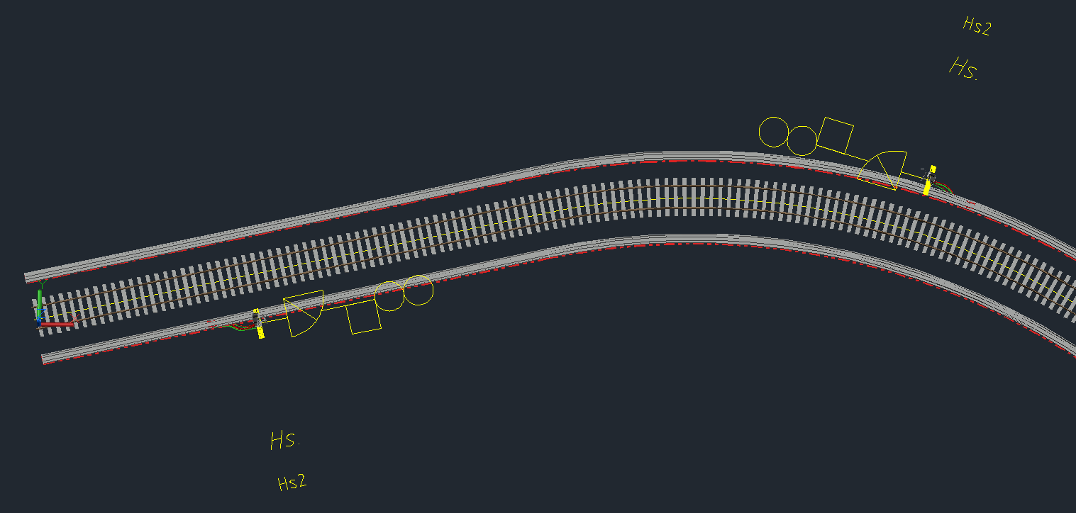

1. Start AutoCAD with RailCOMPLETE, then open the ‘National Tutorials’ folder and locate the DWG file named after this tutorial. You can either type **RC-OpenNationalTutorialsFolder** or you can locate the button below the RC logo in the upper left corner of your AutoCAD window.
2. The example we have prepared contains a single-track railway line with a 3-channel, 60 cm wide cable duct at each side.
3. The cable ducts were created using RC-CreateAlignment with the appropriate RcType selection for cable duct (Norwegian: ‘Kabelkanal’) and the appropriate variant (Norwegian: ‘3-løps’). Instead of drawing them by hand, they were offset with 2.82 meter sideways and -0.35 meter vertically.
4. NOTE: If you try to offset vertically an alignment which does not have any vertical profile data, then the resulting alignment will not contain profile data either.
5. After creating the two cable ducts, we opened the RC-ManageProperties tool, opened the 3D tab, and clicked in the cell named ‘3D Model name’, then clicked on the browser icon (the ellipsis) and changed 3D sweep model from the default model featuring concrete covers to the one 3-channel duct sweep model without covers.  
     
   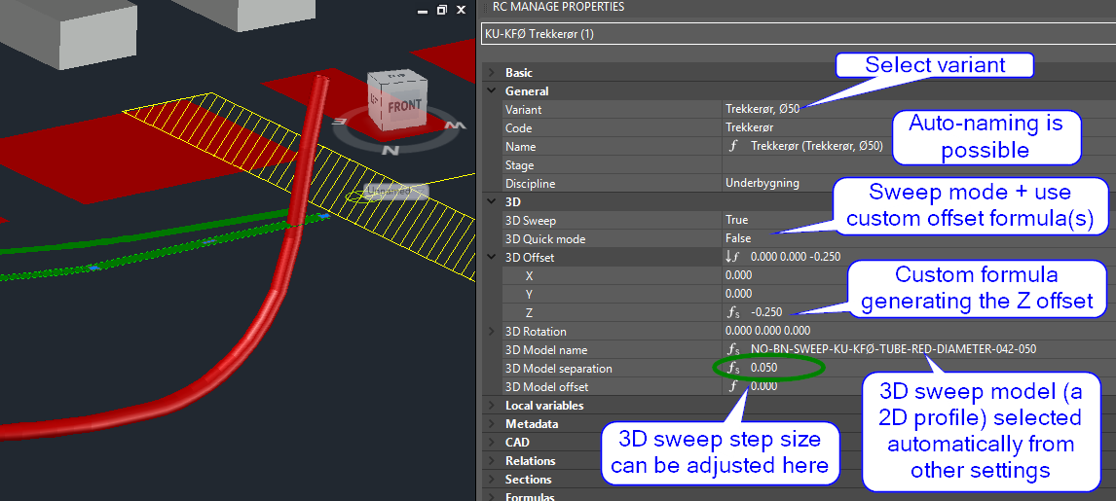
6. Then we enabled RC-Show3DPreview (the cube icon in the ribbon), selected the railway track and the two signals (but not the cable ducts yet) and then copied their 3D previews to the drawing (using the right-click menu, Copy Annotations to Drawing).
7. Activate the CAD system navigation cube, NAVVCUBE/ON (you might have to turn it off first and then on again to make it appear the first time). View your drawing in conceptual or shaded mode, Top view.
8. Deactivate the 3D preview, since the 3D cables will be a nuisance while drawing their 2D geometry.  
     
   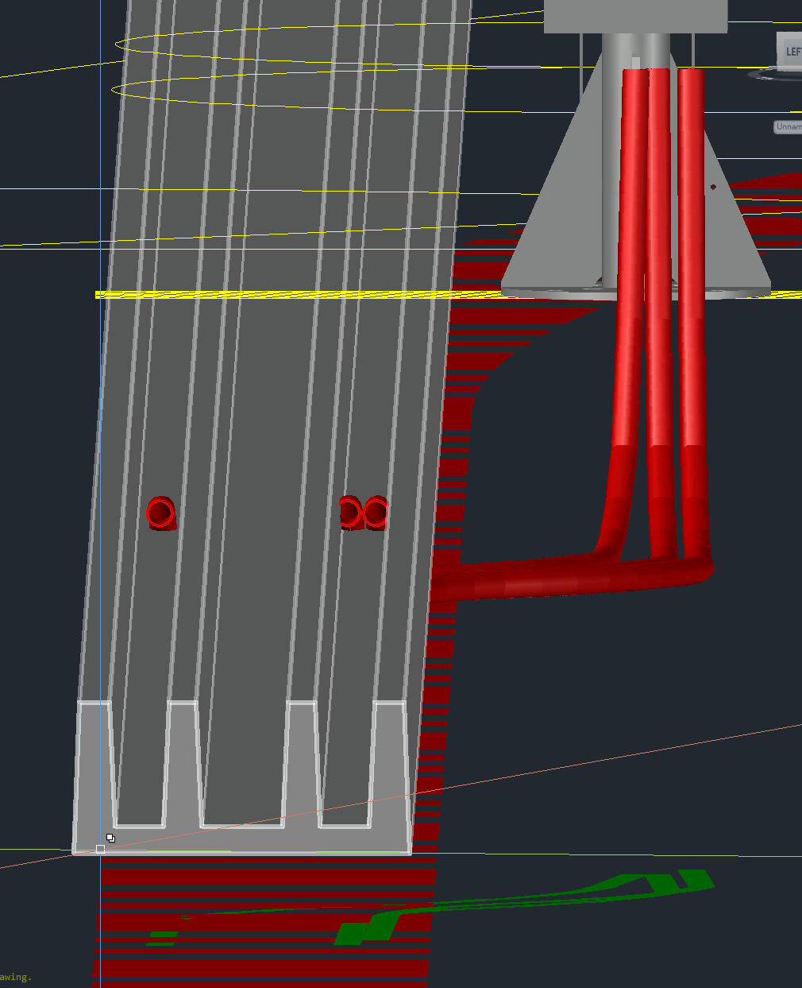
9. Now use RC-CreateAlignment to produce flexible tubes of the category ‘Underbygning / Føringsvei / Trekkerør / Ø050’ (substructure / ducts / flexible tubes / Ø050). Start drawing each tube at its correct distance from centre of cable duct. 3-channel ducts have a quite narrow channel to the left and to the right, and a slightly wider channel in the middle. Let us assume that the signals need one tube from the channel closest to the track, for earthing to a longitudinal earthing wire, and two tubes from the channel farthest from the track, for signalling. Make sure that you respect your local rules for minimum bending radius, for instance 50 cm. Let the tubes end right under each signal’s cabinet, located on the front side of the signal masts.
10. Once you have drawn the tube’s geometries, you can re-active the 3D preview and copy them to the drawing. They will automatically generate a nice Z coordinate along the geometry, consistent with the cable ducts’ Z coordinate (corresponding to the gravel bed surface level that the ducts lie on).
11. NOTE: If the tubes are drawn too short, then the Z offset formula returns a zero offset. The formula needs a geometry length which can accommodate a level part at the beginning, then a cosine-ish descent through the bottom of the cable duct, and at its end a 90 degrees circular arc upwards and a nearly vertical ascent at the very end.
12. NOTE: Alignments cannot be really vertical. I.e. the best we can do is to design a very steep part at the end of the tubes.

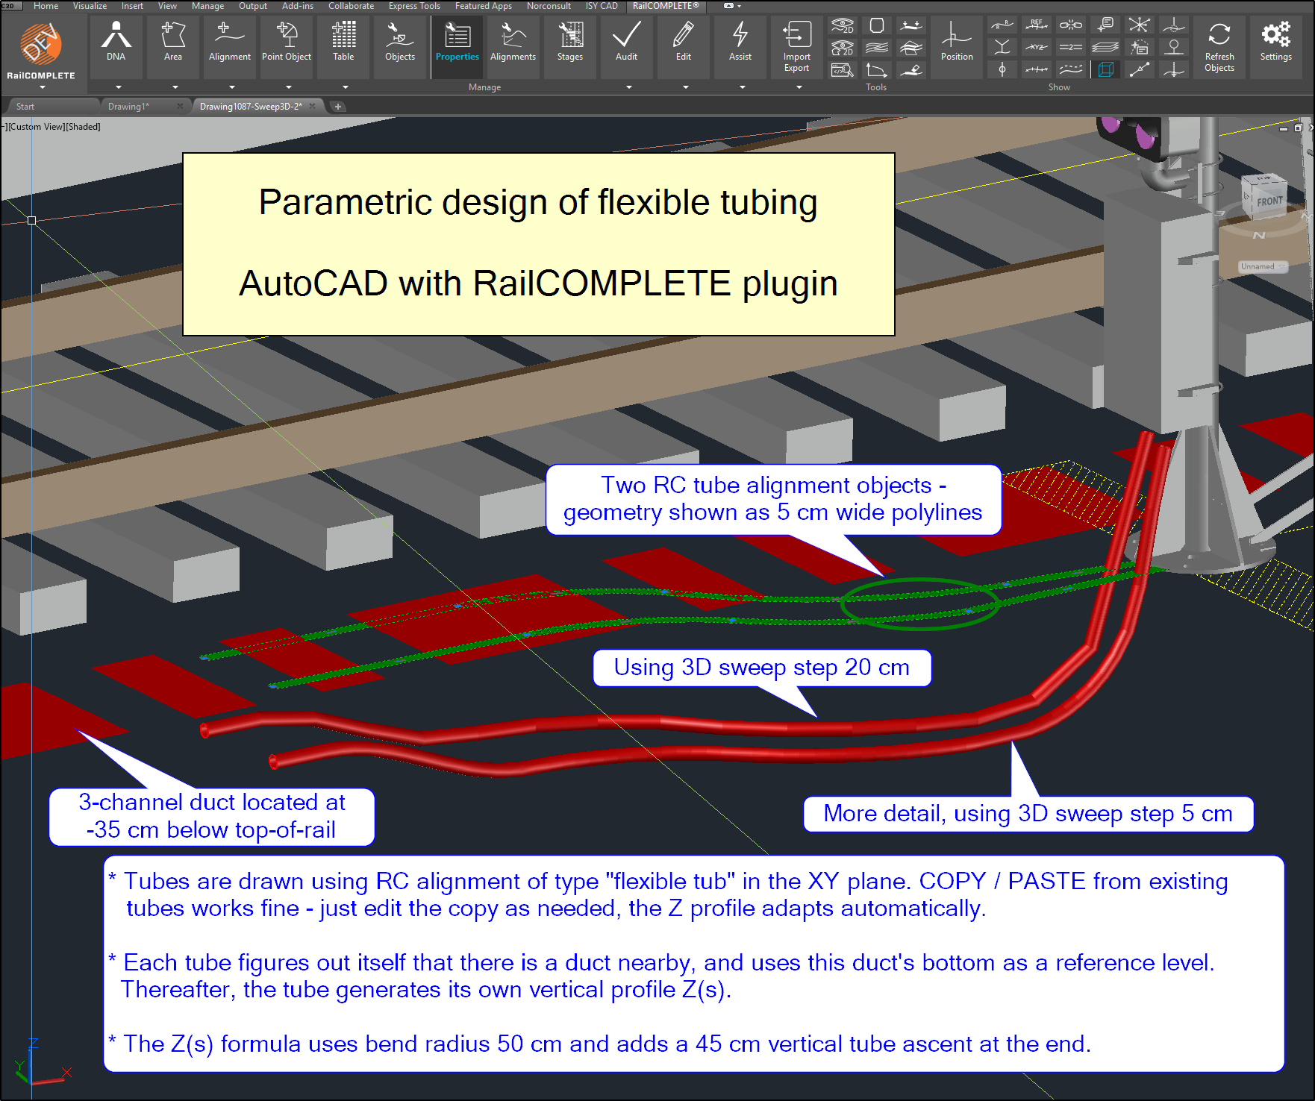

1. Once you are satisfied with your first signal, copy them to the other signal in the example drawing. Place the tube ends under the signal’s mast cabinet, and then rotate the tubes such that their starting points are located in the right chambers. Since the track is curved differently at the second signal, you might have to adjust the tube geometries a little.
2. Use Ctrl+Rightclick/None when manipulating CAD polylines sideways and you want to avoid snapping to the existing polylines for tubes or cable ducts. You can add vertices, remove vertices and change between arcs and lines simply by selecting a polyline and hovering over its grip points, then right-clicking.
3. Re-activate 3D preview and check that your cable duct and tubes fit well.
4. Let us assume that you did not want two Ø050 tubes for signalling at signal #2, but instead you need just one Ø075 tube. Delete one of the signalling tubes and then change Variant to Ø075 for the remaining signaling tube. Adjust the geometry sideways over the cable duct if needed.
5. Select your objects, copy their 3D annotation to the drawing – and you have successfully created flexible tubing for two signals.  
     
   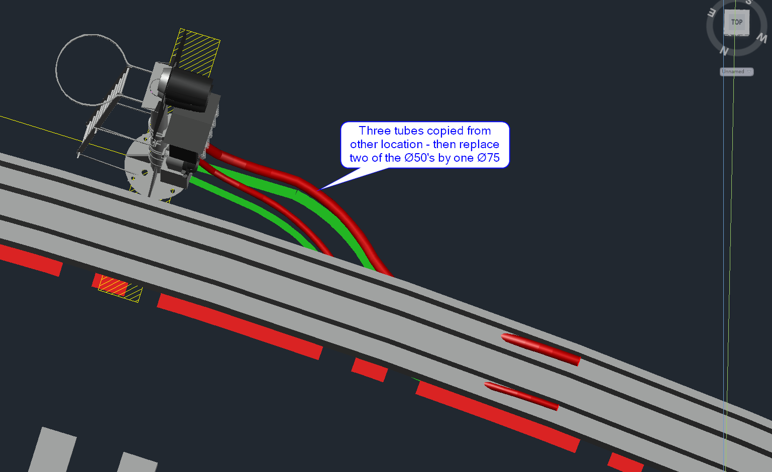
6. (Advanced info): Using RC-ManageProperties and the 3D tab, you can press F3 over the cell named Model3DSeparation. It holds a formula which computes a sample step size for use when sweeping tubes in small straight sweep segments. Your CAD system smooths the transitions when directions change. The formula takes a number as input, representing the approximate step that you need (for instance 0.10 is a suitable trade-off for flexible tubes, whereas the draft 3D for a railway track might use 8 meter to speed up 3D performance). The formula then finds the closest step which will result in an integer number of sweep segments covering the 3D tube exactly from start to end.
7. (Advanced info): Many properties (cells) are driven by formulas. Some are native Lua (like math.cos()), some are part of the RailCOMPLETE/Lua API and cannot be inspected either. But the remaining formulas are usually defined in the DNA, and are open for inspection by you. To see the contents of a formula, open the property (cell) with F3 (Lua editor):  
     
   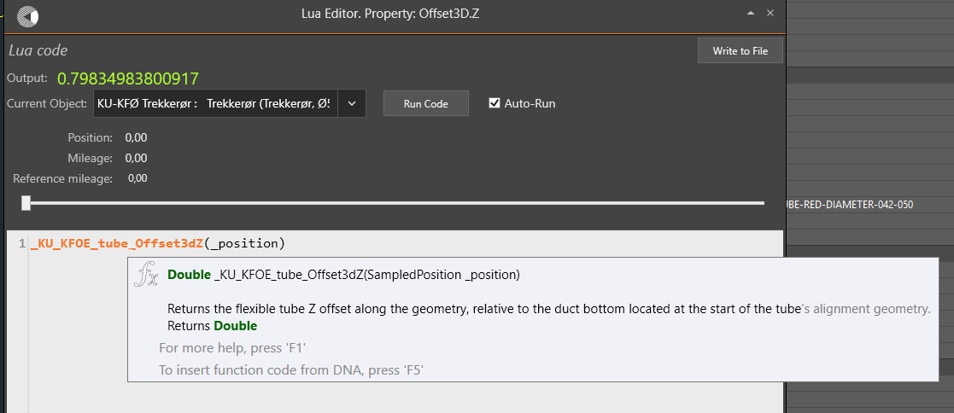
8. Then hover over the function name ‘_KU_KFOE_....’. Since that function has been enabled for inspection (in its DNA declaration), you will see a text explaining that you can click on F5 to insert a local copy of the function (which you may copy or modify). When you try this for the tube’s Offset3D.Z formula, you will see the following formula:  
     
     
   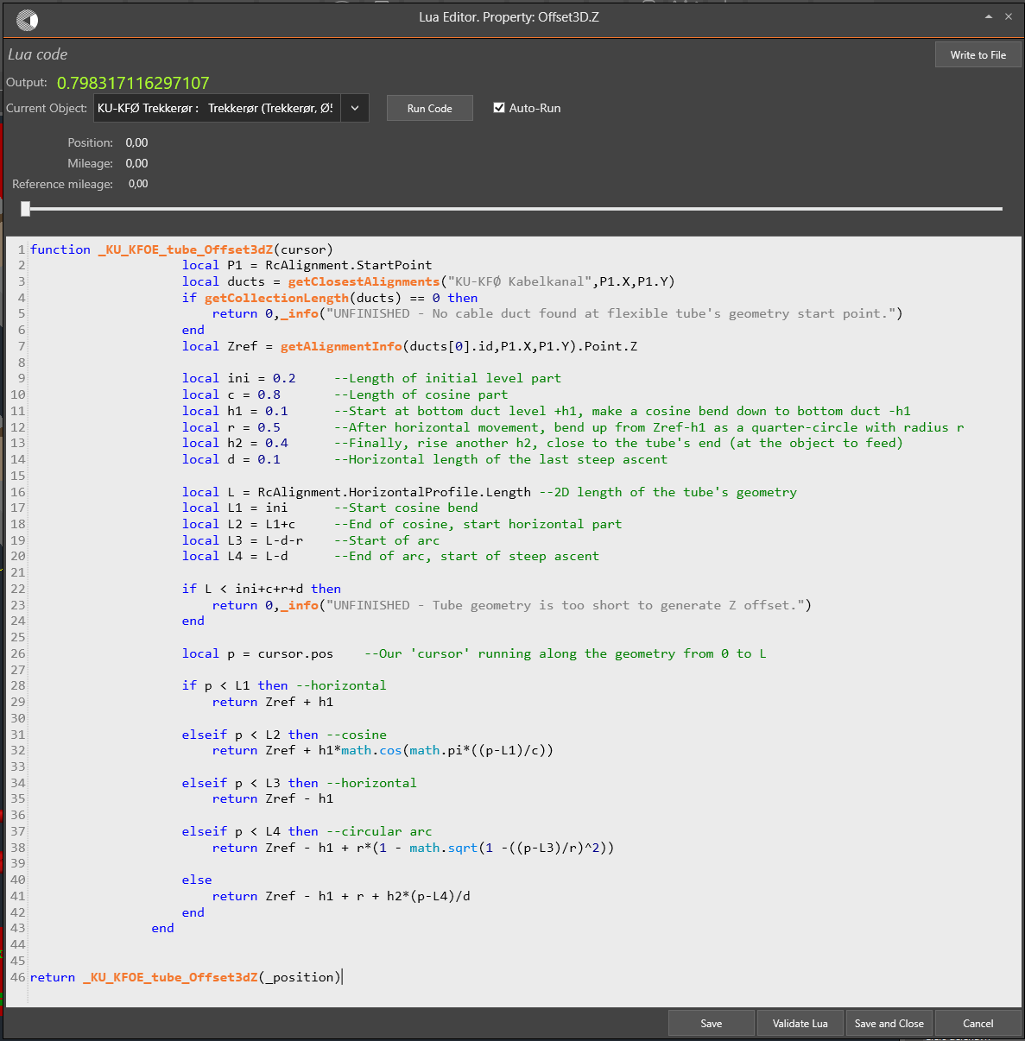

Please check our website www.railcomplete.com for updates.

Corrections and suggestions are welcome to support@railcomplete.no.

Thank you for using RC Tutorials!

1. Your AutoCAD session has probably been started from a Windows shortcut of the type:  
   “C:\Program Files\Autodesk\AutoCAD 2022\acad.exe” /product ACAD /language “fr-FR”, where “fr-FR” means “French language, France’s version”, or similar, or no language specified (English is the native language for AutoCAD). Native AutoCAD commands may have different names in your language pack, other than the COPY, COPYBASE, FIND etc that you see in our tutorial texts. In order to instruct AutoCAD to accept the native English command name, precede the native (English) command name by an underscore character, ‘_’. For instance: ‘_FIND’ will start AutoCAD’s native ‘FIND’ command even if you are using AutoCAD with the French language pack, where the command in French is called ‘RECHERCHER’.If a command needs an argument ‘ON’, and the French menu says ‘Allumer’, then you can enter ‘_ON’ to instruct AutoCAD to use the option’s native name. Furthermore, the English AutoCAD object selection prompt (command _SELECT) accepts many keyboard shortcuts such as A = (add) add to selection set, R = (remove) remove from selection set and AL = (all) all objects (and many more). These shortcuts are named differently in other language packs. In French they are for instance A=ajouter, S=supprimer, TO=tout. Consult AutoCAD Help in your native language.